Q#2: Write a C++ program to enter two numbers and find their sum.

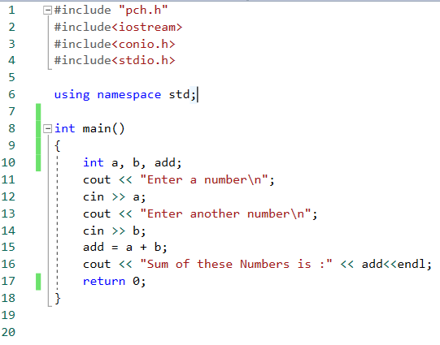

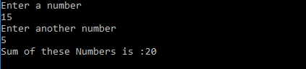

Q#1: Write a C++ program to enter two numbers and perform all arithmetic operations.

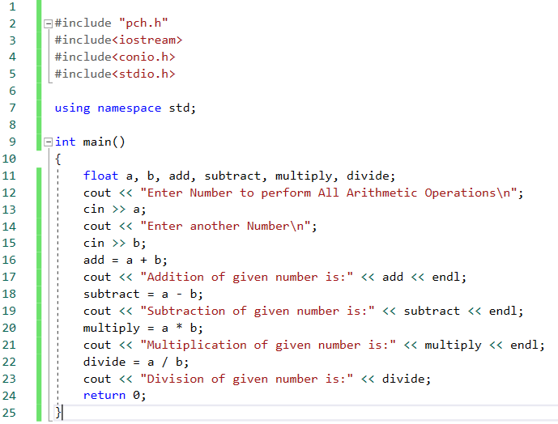

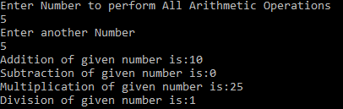

Q#2: Write a C++ program to enter length and breadth of rectangle and find its perimeter.

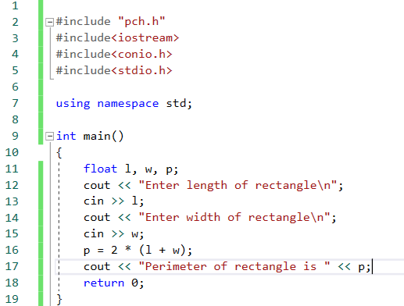

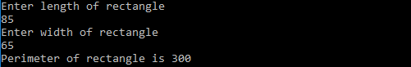

Q#3: Write a C++ program to enter length and breadth of rectangle and find its area.

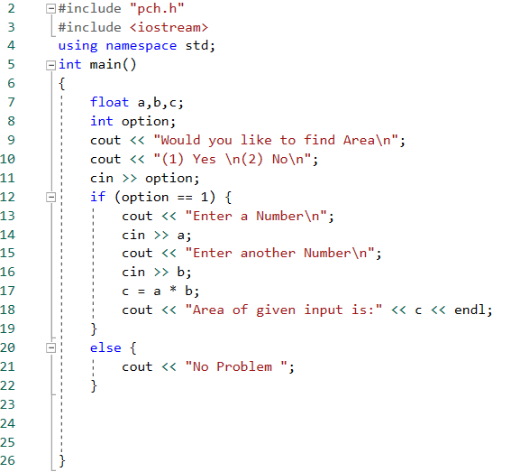

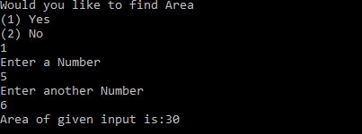

Q#4: Write a C++ program to enter radius of circle and find its diameter,circumference and area.

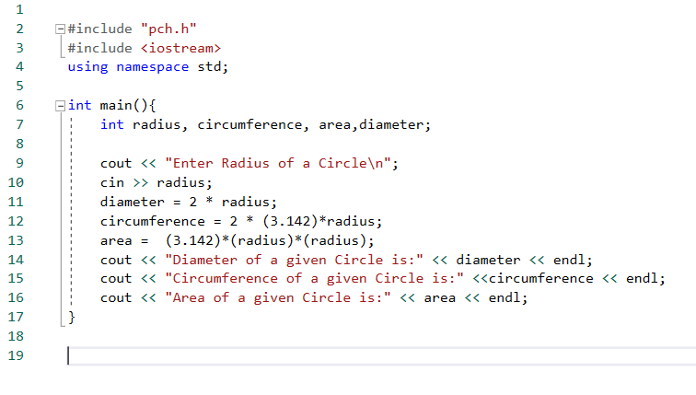

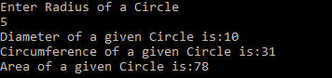

Q#5: Write a C++ program to enter length in centimeter and convert into meter and kilometer.

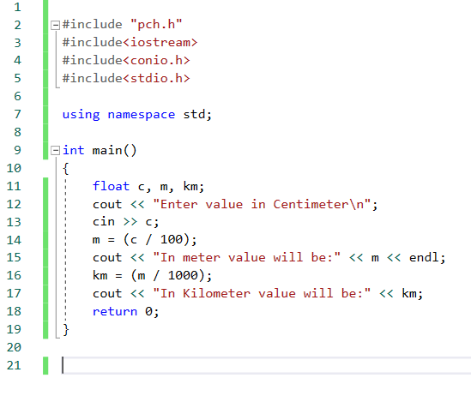

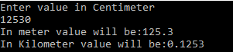

Q#6: Write a C++ program to enter temperature in Celsius and convert into Fahrenheit.

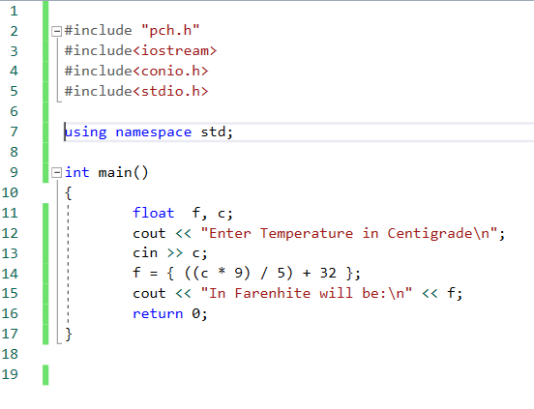

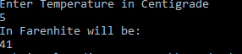

Q#7: Write a C++ program to enter temperature in Fahrenheit and convert into Celsius.

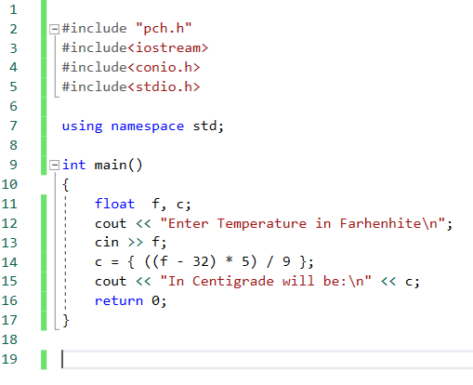



Q#8: Write a C++ program to enter days into years, weeks and days.

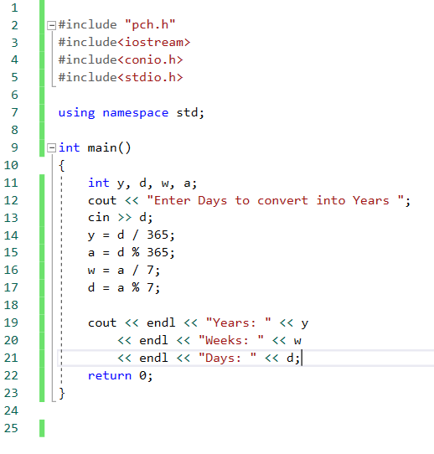

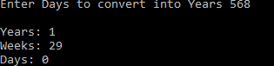

Q#9: Write a C++ program to find power of nay number x^y.

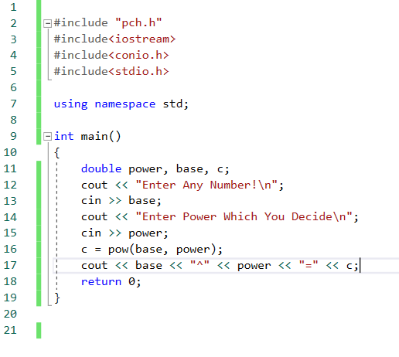

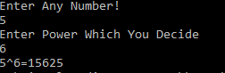

Q#10: Write a C++ program to enter any number to calculate its square root.

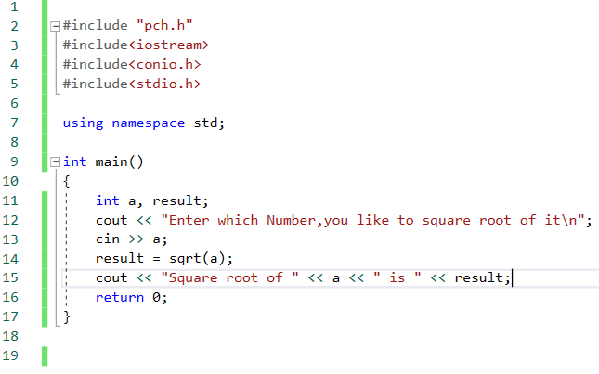



Q#11: Write a C++ program to enter two angles of a triangle and find its third angle.

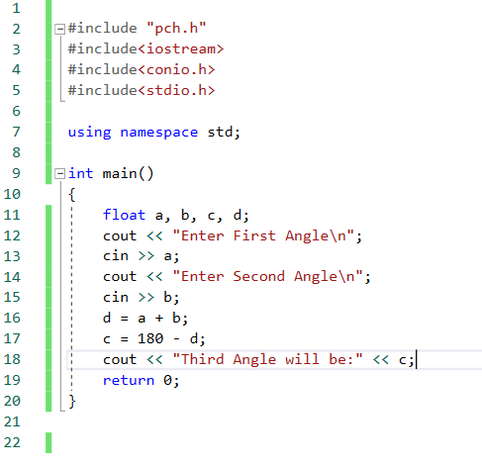

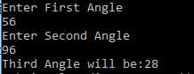

Q#12: Write a C++ program to enter base and height and find its area.

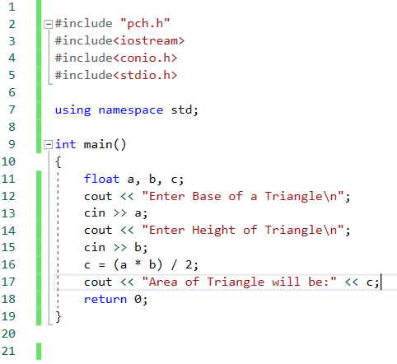

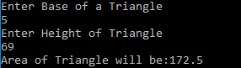

Q#13: Write a C++ program to calculate area of equilateral triangle.

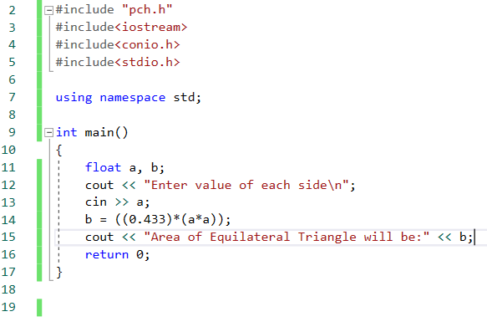



Q#14: Write a C++ program to use p,t,r and find simple interest.

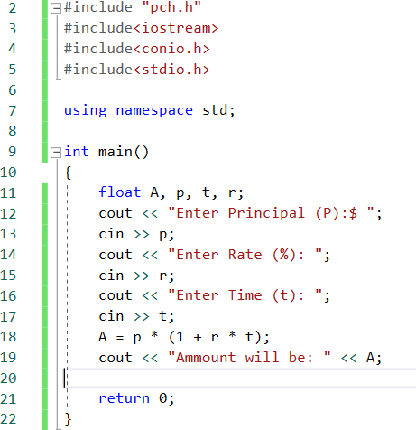

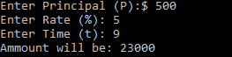

Q#15: Write a C++ program to use p,t,r and find compound interest.

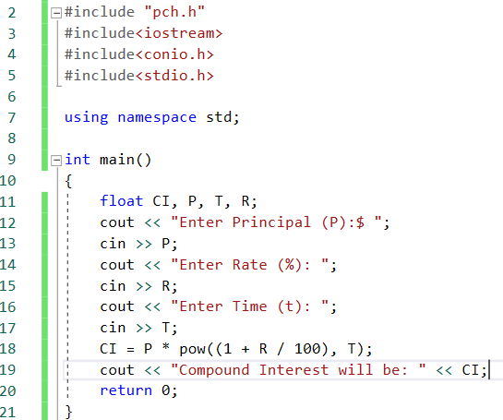



Q#16: Write a C++ program to make a mark sheet of five subject.

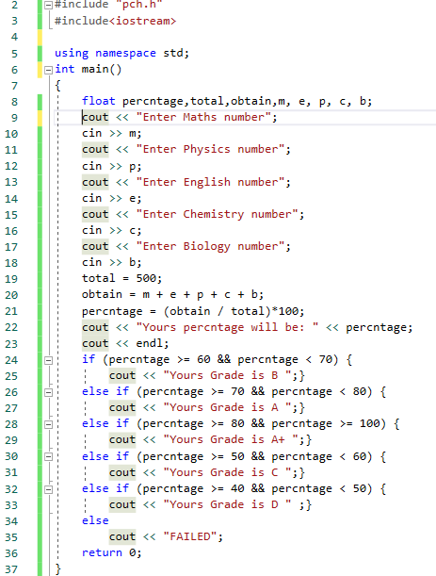

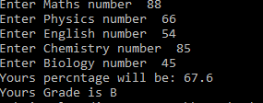

Q#1: Write a C++ program to write Hello World.

